**Create an EFS and connect it to 3 different EC2 instances. Make sure that all instances have different operating systems. For instance, Ubuntu, Red Hat Linux and Amazon Linux 2.**

**Step-1) created security group for ec2 and efs**

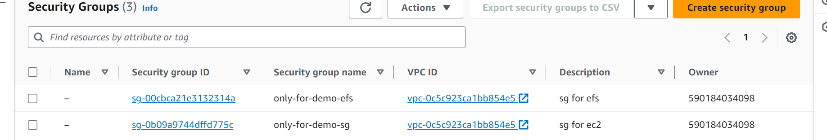

**step-2)created 3 ec2 instance using 3 different Linux, amazon, ubuntu and RHEL ( using EC2-security group)**

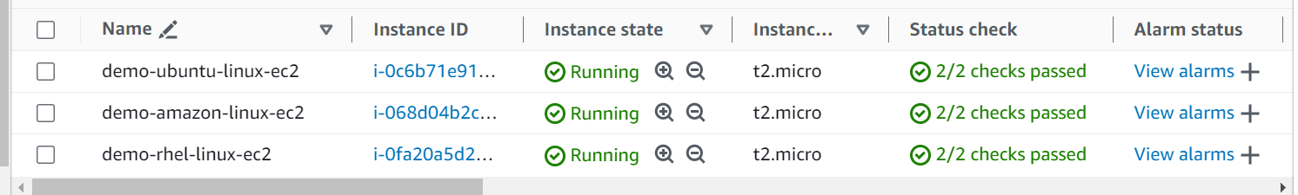

**Step-3) created EFS using NFS security group**

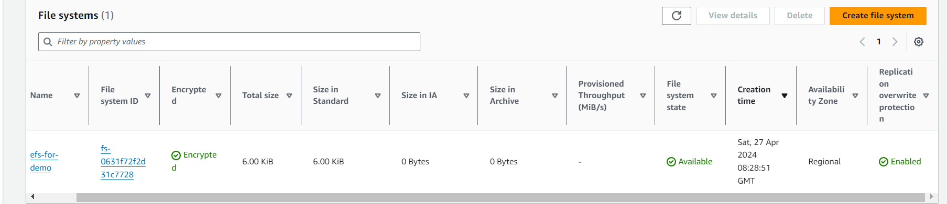

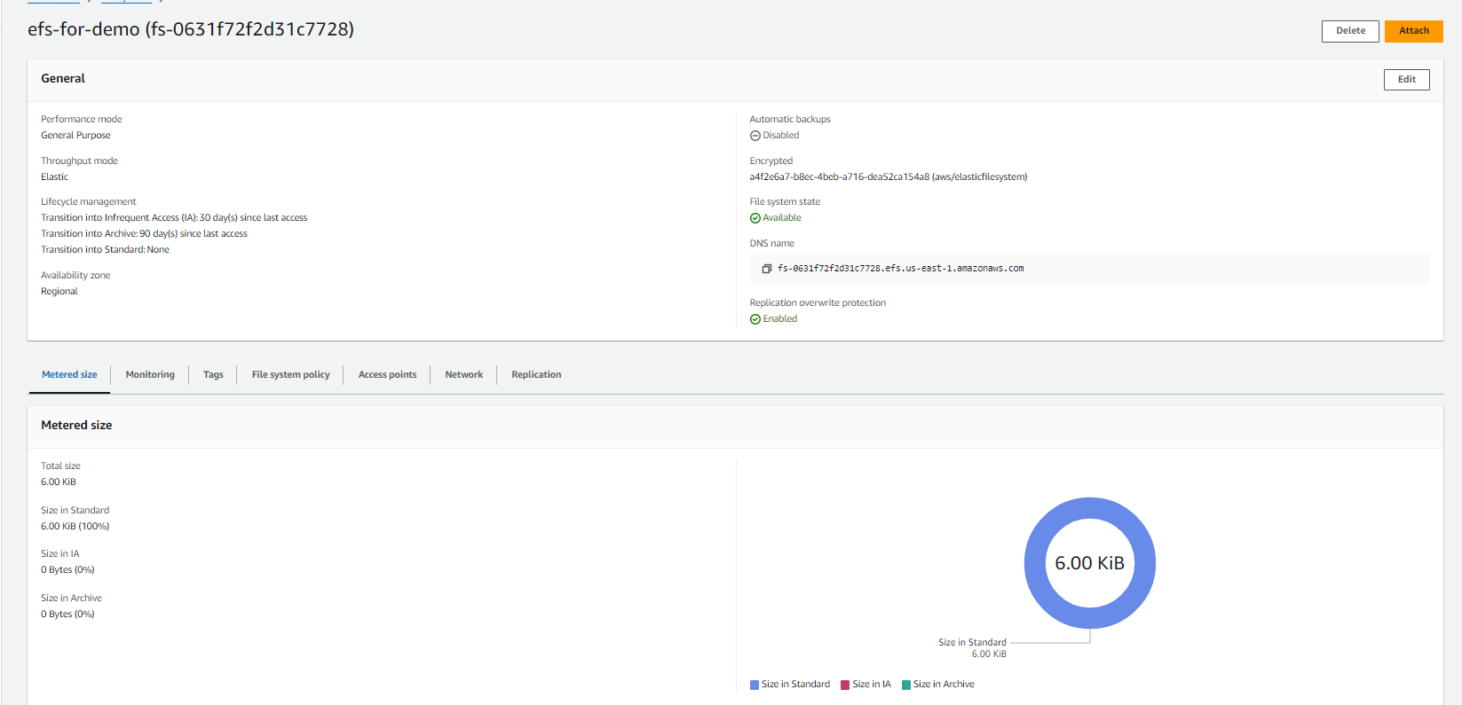

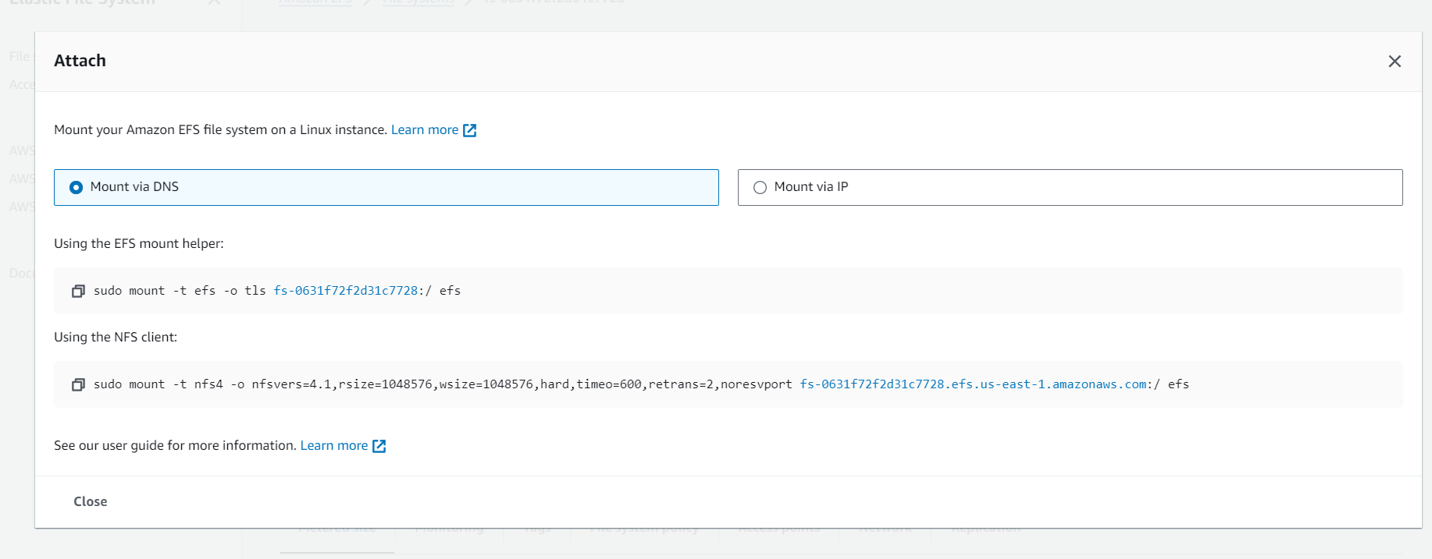

**Step-4) amazon-linux**

**1)opened amazon Linux using EC2-INSTANCE-CONNECT >sudo su**

**2) Manually installing the Amazon EFS client > sudo yum install -y amazon-efs-utils**

**3) created directory > sudo mkdir /karthik1**

**4) mounting done using EFS mounter >using efs mounter**

**5) created text file > echo ‘this file created using amazon linux’**

**6) listed directories using > df -h**

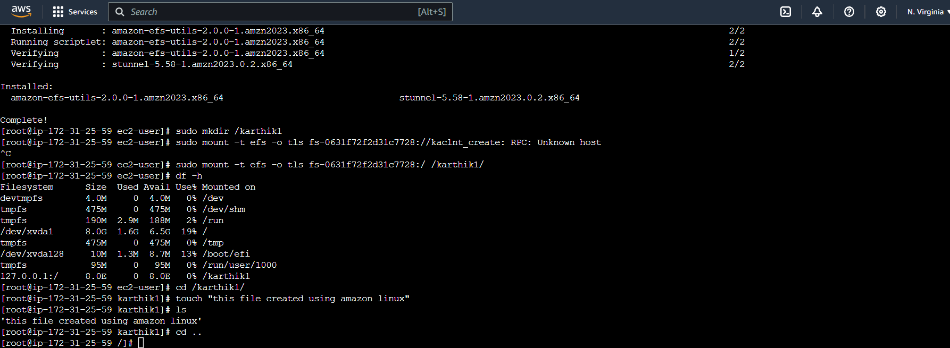

**Step-4) ububtu-linux**

**1)opened amazon Linux using EC2-INSTANCE-CONNECT >sudo su**

**2) Manually installing the Amazon EFS client > sudo apt-get install nfs-common**

**3) created directory > sudo mkdir /karthik1**

**4) mounting done using EFS mounter >using efs mounter**

**5) created text file > echo ‘this file created using amazon linux’**

**6) listed directories using > df -h**

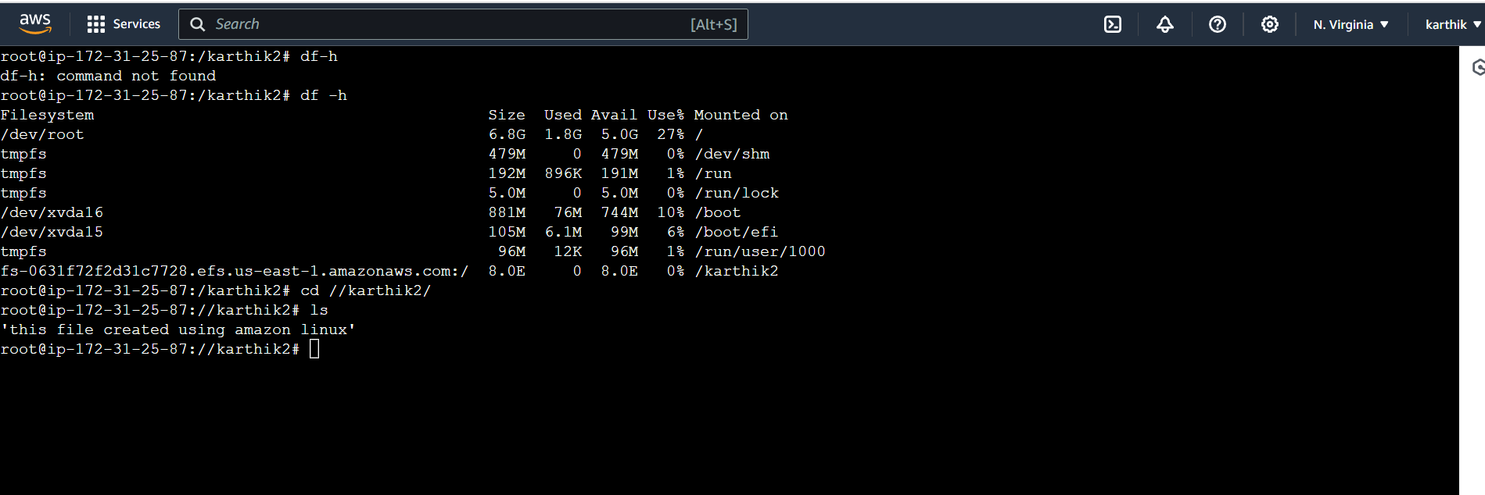

**Step-4) ububtu-linux**

**1)opened amazon Linux using EC2-INSTANCE-CONNECT >sudo su**

**2) Manually installing the Amazon EFS client > sudo update -y nfs-utils**

**3) created directory > sudo mkdir /karthik1**

**4) mounting done using EFS mounter >using efs mounter**

**5) created text file > echo ‘this file created using amazon linux’**

**6) listed directories using > df -h**

